Journals to Take Action Filters

In the event that filters for the journals you must act upon have not been pre-configured for your User ID, you can still set them up manually.
- The “Action” statement will be in red-colored font, and you need to click on “Edit Filters.”
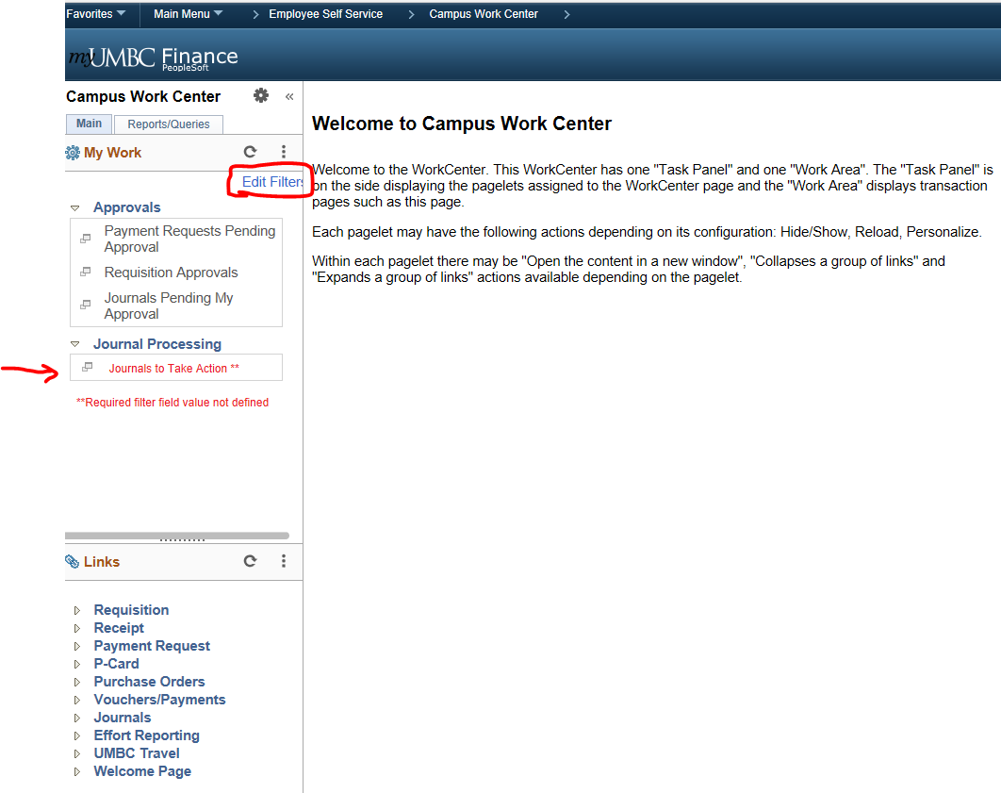
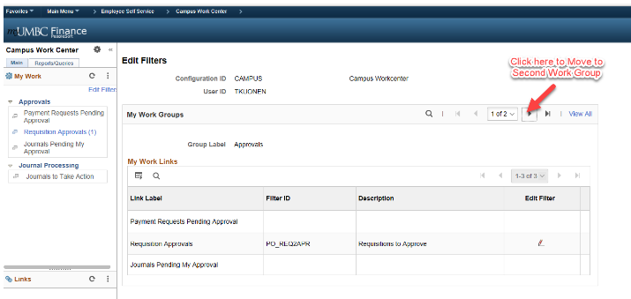
- Proceed to sequence #2, Group Label = Journal Processing
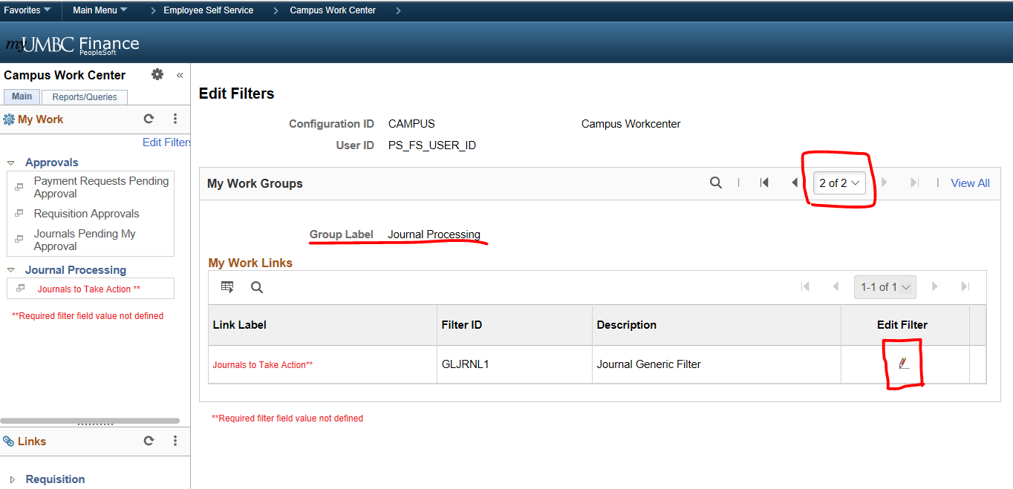

(continued on next page)
- On the filter value screen, fill-in the following 4 values and click “OK”
